Y1Q4W7&8

Elijah

Ask: What do babies need to be happy?
Ask: Can they get these things for themselves?
Handout: The needs sheet. Say: Tick the things that you need to live happily.
Say: If you had to do without one of the things you ticked what would it be? – cross it out.

Say: God has promised that He will supply the needs of His people, and today we are going to find out how He did this for one of His prophets.

Bible Story - DVD

Sing Songs

Return to tables
Memory Verse: Fill in the blanks and then say the memory verse on the colouring page.
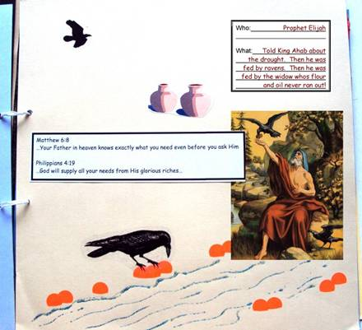
Scrapbooks
Elijah is fed by ravens
- Choose a cardboard
- Stick on the picture, verse and description cards.
- Stick on the birds.
- Make sure your name is on it
- Lastly use the glitter glue to draw water and set it aside to dry

Discuss the following depending on age, interest and time:
What is the difference between a need and a want?
Do your younger brothers or sisters ever think they need something that you don't think they do? (Anything of yours?)
Do you ever think you need something and your parents disagree?
Do you think that people ever think they need something but God knows better? Examples?

Read the Story: (Guides greatest Miracle Stories p113 "Day of Miracles")

Ask: What should we do when we need something?
Ask: What should we think if God doesn't seem to answer?
Say: It might mean that it is not a good thing for us, or that God is planning something even better for us. We might not know why God does thing now, just like you might not understand why Mummy or Daddy do something's now, but when you get to heaven you can ask Jesus and you can be sure that He had a really good reason, and that you will be happy with what He did.

Primary / Junior / Teen: This term, those of you who would like to get a Bible to take home, may take one of the orange Commandment pages and add to your book. Each week you come you can put a sticker on it and when it is all complete we will get you a Bible to take home and keep.

Finish with prayer.

